**WEB DEVELOPMENT STACKS**

The world has changed to a mobile-first era but even today, none of the applications could emerge as effective as the web-based apps. Surfacing on top of this is the prevalence of progressive web apps that perform functions identical to mobile apps. So, it’s pretty clear that web apps are going to stay and for long. What makes these web applications worth investing is the use of high-end scalable technologies for the development.

Selecting the most popular web technology stack 2022 for your software development helps in enhancing your business prospects and boosting your profitability ratio. There are multiple stacks available in the market today.

**Stats for web development stacks**

According to the most recent stats by the World Wide Web Consortium (W3C), this industry is estimated to reach $31 Trillion by the end of 2022 with an annual increase rate of 5%. The total number of worldwide sites developed in the same year is 2 billion.

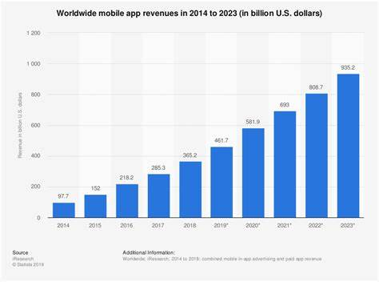

More on web development statistics in top companies are,

* The number of sites owned by Amazon is 70K.
* The number of sites owned by Google is 3M.
* The number of active users on Facebook 2.4B monthly.
* The number of monthly active users on YouTube is 1B.

These stats are attractive and enough to extend the worldwide use of

Web development technologies in 2022.

**What is web development stack?**

A **web development** [**technology stack**](https://mixpanel.com/topics/what-is-a-technology-stack/) is also known as a solutions stack, data ecosystem, or technology infrastructure. It is a set of technology tools or service developers used to create and run applications.

**Types of web development stack**

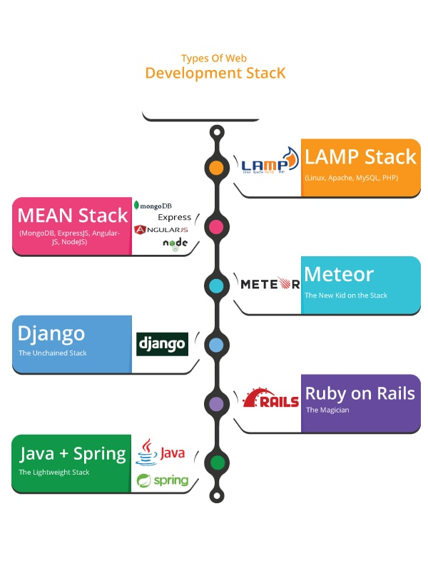

Let’s have a look on types of stacks available in the industry,

**1.The MEAN Technology Stack**

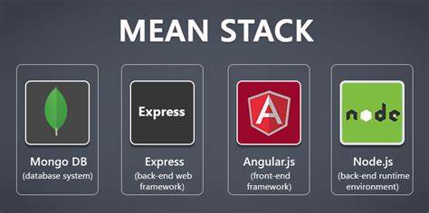

It is the best stack for web development services with its numerous benefits for software developers. The MEAN stack comprises MongoDB (NoSQL DB), Express.js (backend web frame work), Angular.js (front-end framework), and Node.js (opensource cross platform server) and is used in developing complex mobile and web responsive applications.

JavaScript is the single language that is used throughout the stack and that is why it tops the best web stack 2022list. The components are JSON savvy and great in data transmission with free module library access. This means that the code can be reused across the entire app without reinventing further.

**When to use MEAN stack for Web development?**

* MEAN Technology supports fast real-time web apps.
* Reduce the execution time of the project.
* Faster integration with client and server panels.
* More flexible and adaptive with technologies.
* Freely available as open-source.
* Project developed in MEAN is well fit on a budget.

**2. The MERN Technology Stack**

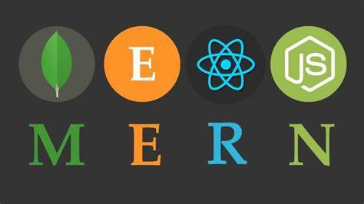

MERN is nearly akin to MEAN with a slight change in technology where in Angular.js is exchanged with React. The major benefit of using MERN is the integration of React, its power library source, its capability to use codes simultaneously on servers and browsers along with its full-stack development possibilities. React uses JavaScript XML and virtual DOM whereby component work and changes can seamlessly implemented.

**When to use MERN stack?**

* Power-packed with numerous libraries and codes.
* Faster emulsion with client and server-side.
* Presence of extensive tools due to its open-source platform.
* The project is the best fit on a budget, and higher on performance.

**3. The LAMP Technology Stack**

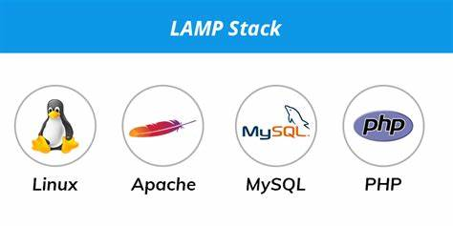

Linux Web Servers are made up of four software parts. These components, arranged in layers supporting one another, make up the software stack. Web Applications works on the higher level of this stack.

The LAMP stack comprises comprises of Linux (OS), Apache Server, MySQL (database), PHP.

**4. The METEOR Technology stack**



Meteor runs on a JavaScript programming platform for creating web-based and mobile applications. This Full Stack has a set of high technologies to build applications that are reactive and a building tool.

**When to use METEOR stack?**

* It makes the user create or develop web-based applications in one single scripting language which is JavaScript in all available environments like browsers, mobile equipment, and application-based servers.
* It brings user an extremely super-fast JavaScript programming kit in a highly effective way.

**5.The Technology Ruby on Rails Stack**

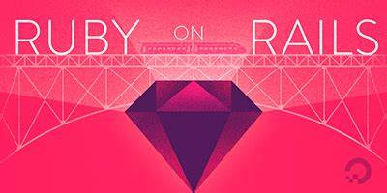

Ruby on Rails is one of the most used and popular web application frameworks and it is available on the web as an open-source full-stack. The Ruby on Rails is entirely built with a programming language, Ruby.

It is used for building applications that are complex and also very simple applications. There is no boundary with ruby on rails for creative web-based application development.

Any number of interactive features can be developed in a user-friendly manner. Some of the popular sites that used ruby on rails are Scribd, Github, ask.fm, twitch, Shopify, Soundcloud, Zendesk, Kickstarter. All of these popular companies have taken the usage of ruby on rails to help their customers in a better way.

**6.The Technology Lightweight Stack- Java & Spring**

Spring is full stack framework process runs on Java Scripting language. This Framework is considered to be the most light-weight framework structure because in no way its harmful to the web application creation. IT weighs around 2MB and it is one of the tiny framework elements.

The tiny framework eliminates most of the developer tasks like interface implementation and makes the developers concentrate on innovative feature development for a web-based application. Injection of dependency is the concept used to combine components altogether.

I hope you are aware of full stack types and their advantages by now. Always go for best tool to increase your business success and also get into fine career with good pay!....